**PROJECT REPORT ON**

**“UNDER VOLTAGE AND OVER VOLTAGE PROTECTION SYSTEM”**

**Submitted in the partial fulfillment of the requirement**

**of**

**Diploma in Electrical and Electronic Engineering**

**Telecommunication**

**BY**

**Edwin Gikera Gicharu**

**Index: 2051011854**

**Under the guidance**

**Prof.Ruth Gaiti**

**Department of Electrical, Electronics**

**Kiambu Institute of Science and Technology**

**2019-2022**

**CERTIFICATE**

## This is to certify that Project titled

**“UNDER VOLTAGE AND OVER VOLTAGE PROTECTION SYSTEM”**

Submitted By

**Edwin Gikera Gicharu**

**Index: 2051011854**

Is completed as per requirement of

**K.N.E.C**

In partial fulfillment of Diploma in Engineering

For Academic year 2022

Guide:Madam Ruth Gaiti

1. O.D:Mr Muradi

Principal:Mr Waititu

**ACKNOWLEDGEMENT**

Every work begins with a systematic approach. Our project work doesn’t, at all, make an

exception.

The project was dynamic and it was for us to synchronize the practical experience in

“***UNDER VOLTAGE AND OVER VOLTAGE PROTECTION SYSTEM***”, with the knowledge

that we already acquired from our books. So certainly this kind of work needs some special kind of Endeavour, incentive and inspiration.

Our teachers are inspiration for us for doing every activity on the educational field. Their teaching of spontaneous encouragement gives new direction to the work. As a result of this gives an immense and great pleasure to express our deep sense of gratitude to our guide ***Prof.Ruth Gaiti*** for his valuable guidance and co-operation in this project. We’re thankful for his coherent encouragement which provided the needed platform.

We’re thankful to our respected H.O.D. ***Prof.Muradi*** for his valuable time showering up & his timely encouragement and also lastly we express our deep gratitude to all who has given an encouragement to complete our project successfully. We also express our sincere gratitude to the entire faculty members of our department for their valuable help & co- operation.

We also extend our thanks to our respected Principal ***Prof.Waititu*** for given us the opportunity to work on this project.

## Yours sincerely,

## EDWIN G GICHARU (2051011854)

|  |  |  |  |
| --- | --- | --- | --- |
| **Chapter**  **No.** | **Subtopic**  **No.** | **Name of Chapter** | **Page**  **No.** |
| **1** |  | **Introduction** | **1** |
|  | 1.1 | Introduction | 2 |
| 1.2 | Necessity | 2 |
| 1.3 | Objective | 2 |
| 1.4 | Theme | 2 |
| **2** |  | **Literature Survey** | **3** |
|  | 2.1 | Overvoltage | 3 |
| 2.1.1 | Cause of Overvoltage | 3 |
| 2.2 | Under voltage | 6 |
| 2.2.1 | Causes of Under voltage | 7 |
| 2.3 | Power Quality | 8 |
| 2.4 | Types of Load | 9 |
| 2.5 | Introduction to Protection System | 10 |
| 2.5.1 | Application of Protection System | 11 |
| 2.5.2 | Advantages of Protection System | 11 |
| 2.6 | Mitigation Techniques | 12 |
| **3** |  | **System Description and Hardware Implementation** | **20** |
|  | 3.1 | Block Diagram | 20 |
| 3.2 | Working | 20 |
| 3.3 | Circuit Design | 21 |
| 3.4 | Circuit Working | 21 |
| 3.5 | Hardware Implementation | 23 |
| 3.5.1 | Component Selection and Description | 23 |
| 3.5.2 | Hardware Details of the System | 23 |
| **4** |  | **Discussion and Result** | **37** |
|  | 4.1 | Discussion | 37 |
| 4.2 | Result | 38 |

|  |  |  |  |
| --- | --- | --- | --- |
| **5** |  | **Conclusion** | **41** |
|  | 5.1 | Conclusion | 41 |
| 5.2 | Future Scope | 41 |
|  | References |  |
|  | Appendix |  |

**List of Abbreviations**

|  |  |  |
| --- | --- | --- |
| **Sr. No.** | **Abbreviation** | **Full form of Abbreviation** |
| 1 | Ckt. | Circuit |
| 2 | AC | Alternating Current |
| 3 | DC | Direct Current |
| 4 | IC | Integrated Circuit |
| 5 | Vtg. | Voltage |
| 6 | Dissp. | Dissipation |
| 7 | RL | Relay |
| 8 | N/C | Normally Closed |
| 9 | N/O | Normally Open |
| 10 | SMS | Short Message Service |
| 11 | GSM | Global System for Mobile Communication |
| 12 | T1 | Transistor 1 |
| 13 | R.M.S. | Root Mean Square |
| 14 | PCB | Printed Circuit Board |
| 15 | ASD | Adjustable Speed Drive |
| 16 | PLC | Programmable Logic Controller |
| 17 | SVC | Static Var Compensator |
| 18 | DVR | Dynamic Voltage Restorer |
| 19 | UPS | Uninterruptable Power Supply |
| 20 | Pot. | Potentiometer |

|  |  |  |
| --- | --- | --- |
| **Sr. No.** | **Figure No.** | **Name of Figure** |
| 1 | 2.1.1.1 | Ferroresonant Circuit with cable fed transformer with an ungrounded  high side connection |
| 2 | 2.1.1.2 | Fault from a transmission conductor to distribution conductor |
| 3 | 2.6.1 | Controlled ferroresonant transformer |
| 4 | 2.6.2 | Block diagram of Off-line UPS |
| 5 | 2.6.3 | Block diagram of On-line UPS |
| 6 | 2.6.4 | Basic flywheel and Motor-Generator Configuration |
| 7 | 2.6.5 | Impact of Sun Incidence angle on Solar cell Output |
| 8 | 2.6.6 | Block diagram of DVR |
| 9 | 2.6.7 | Block diagram of SVC |
| 10 | 2.6.8 | Block diagram of sag proofing transformer |
| 11 | 3.1.1 | Block diagram of protection system |
| 12 | 3.3.1 | Circuit diagram of protection system |
| 13 | 3.5.2.1 | Low voltage step down transformer |
| 14 | 3.5.2.2 | Bridge rectifier (positive half cycle) |
| 15 | 3.5.2.3 | Bridge rectifier (negative half cycle) |
| 16 | 3.5.2.4 | IC 7812 |
| 17 | 3.5.2.5 | Pin configuration of LM 324 |
| 18 | 3.5.2.6 | Zener Diode |
| 19 | 3.5.2.7 | Characteristic curve of zener diode |
| 20 | 3.5.2.8 | Relay |
| 21 | 3.5.2.9 | Potentiometer |
| 22 | 3.5.3.0 | Schematic diagram of potentiometer |
| 23 | 3.5.3.1 | Transistor |
| 24 | 3.5.3.2 | Resistors |
| 25 | 3.5.3.3 | Capacitor 470 µF |
| 26 | 3.5.3.4 | Capacitor 0.1 µF |
| 27 | 4.1.1.1 | Circuit diagram of protection system |

|  |  |  |
| --- | --- | --- |
| 28 | 4.1.3 | Circuit implementation |
| 29 | 4.2.1 | Normal voltage supply |
| 30 | 4.2.2 | Under voltage supply |
| 31 | 4.2.3 | Over voltage supply |

**List of Graphs**

|  |  |  |
| --- | --- | --- |
| **Sr. No.** | **Graph No.** | **Name of Graph** |
| 1 | 2.1.1 | Overvoltage |
| 2 | 2.2.1 | Undervoltage |

**List of Tables**

|  |  |  |
| --- | --- | --- |
| **Sr. No.** | **Table No.** | **Name of Table** |
| 1 | 2.1.1.2 | Classification of overvoltage according to IEEE 1159 |
| 2 | 2.2.1 | Classification of under voltage according to IEEE |
| 3 | 2.5.1 | Different voltage Condition |
| 4 | 3.5.2.1 | Pin Description of LM324 |
| 5 | 3.5.2.2 | Absolute maximum rating of Transistors |
| 6 | 3.5.2.3 | Resistors Used |
| 7 | 3.5.2.4 | Capacitors Used |

**Chapter 1: Introduction**

* 1. **Introduction**

Actually sudden fluctuation in voltage is very big and serious problem in industries and home appliances and it causes losses in electrical circuits. These losses causes low power factor in the supply and by much amount of power is going to be wasted. These fluctuations may significantly impact the power quality as well as the reliability of other voltage controlling devices. Therefore due to this fluctuation various costly and precious equipments may get damaged.

When RMS voltage or current drops between 0.1 and 0.9 pu at the power frequency for durations of 0.5 cycles to 1 minute then it is said to be sag condition. The swell condition will occur when RMS voltage or current rise between 1.1 and 1.8 pu at the power frequency for durations of 0.5 to 1 minute. And above the 1.8pu and below 0.9pu is called over voltage and under voltage respectively. Voltage sags and under voltage conditions are caused by abrupt increases in loads such as short circuits and faults or it is caused by abrupt increase in source impendence, abruptly caused by loose connection. Voltage swells and over voltage conditions are almost always caused by an abrupt decrease in load on a circuit with a poor or damaged voltage regulator, although they can also be caused by a damaged or loose neutral connection.

So, the problems occurred due to sag, swell, over and under voltage condition should be removed and it will be detected and protected by this system. In this paper we implement a circuit which helps to detect the voltage below 198 volt which is 0.9 of rated voltage which is 220 volt and it is sag and under voltage condition and in this condition our circuit will remain in open condition so there will on any passage of current. In this condition lower relay of our circuit will remain open. When the voltage rises above 242 voltages which is 1.1 of our rated voltage and it is swell and over voltage condition, in this situation the circuit will remain open because in that time upper relay in the circuit will remain open. Thus we can protect the costly equipment’s by passing the supply through this circuit.

## Necessity

Now day’s high quality power is basic need of highly automated industries and home appliances. So this high quality power may be got by the help of this circuit and it will improve the power factor and thus power can be fully utilized. In this way, we can remove our sag, swell, over and under voltage problems and get benefited.

Protection against sudden overvoltage’s in substations is a vital part of the overall reliability of power systems. The degree of surge protection afforded to a station is governed by the reliability required and the economics to obtain such reliability. Since major stations generally include strategic and highly valuable power equipment, surge protection is essential to avoid or minimize major system disturbances as well as major equipment failures. Transient overvoltage occurring in our power system can cause operational breakdown and also cause failure in industrial and household equipments as well.

The protection from overvoltage is mainly necessary for Humans because the peoples are dead due to overvoltage shock.

## Objective

The objective of this system is to provide protection to the equipment’s and avoid their failure due to abnormal conditions. This system provides protection for industrial, commercial and residential equipment’s.

## Theme

The process of this system is whenever there an overvoltage or under voltage the relay sense the input from operational amplifier and gets trip and the load is off. Thus it protects the electrical appliance.

# Chapter 2: Literature Survey

## Overvoltage

A Overvoltage is defined as an increase in the r.m.s. value of the voltage up to a level between 1.1 pu to 1.8 pu at power frequency for periods ranging from a half cycle to a minute as shown in fig 2.1.1

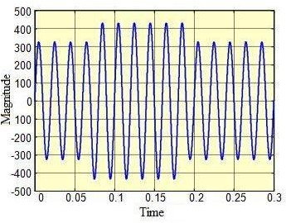

## Graph 2.1.1: Overvoltage [1]

* + 1. **Causes of Overvoltage**

Overvoltages are less common than under voltage but they also arise due to system faults. Overvoltage can occur due to single line to ground fault, which in turn will raise the voltage of the other phases. It can also cause due to disconnection of heavy industrial loads or switching on the capacitor banks. This is generally due to ungrounded or floating ground delta systems, where a change in ground reference would give voltage rise to the ungrounded system.

## Table 2.1.1.2: Classification of overvoltage according to IEEE 1159

|  |  |  |
| --- | --- | --- |
| Types of Voltage | Duration | Magnitude |
| Instantaneous | 0.5 – 30 cycles | 1.1 – 1.8 pu. |
| Momentary | 30 cycles – 3 sec | 1.1 – 1.4 pu. |
| Temporary | 3 sec – 1 min | 1.1 – 1.2 pu. |

Causes of overvoltage are mainly due to energization of capacitor bank. It can also be generated by sudden load deduction. Due to the disconnection of load there is a sudden reduction of current, which will give rise the voltage, where L is the inductance of the line. The effects of

overvoltage are more severe and destructive. It may cause the electrical equipment to fail, due to overheating caused by high voltage. Also electronic and other sensitive equipment are prone to malfunction [1].

## Some more causes of Overvoltage are given below.

* + - 1. **Loss of a Secondary Neutral**

Open neutral connections in 120/240-V customer installations can occur and have been reported under several circumstances, including:

* When corrosion of an underground service reaches an acute stage
* When the neutral wire of a separate-conductor service drop is broken by falling branches or Icing
* When an intermittent loose connection exists in the service panel

## Ferroresonance

Ferroresonances is a special form of series resonance between the magnetizing reactance of a transformer and the system capacitance. A common form of ferroresonance occurs during single phasing of three-phase distribution transformers. This most commonly happens on cable-fed transformers because of the high capacitance of the cables. The transformer connection is also critical for ferroresonance.

An ungrounded primary connection leads to the highest magnitude of ferroresonance. During single phasing (usually when line crews energize or de-energize the transformer with single-phase cutouts at the cable riser pole), a ferroresonant circuit between the cable capacitance and the transformer’s magnetizing reactance drives voltages to as high as five per unit on the open legs of the transformer. The voltage waveform is normally distorted and often chaotic [6].

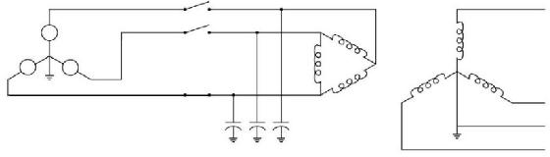

## Fig. 2.1.1.1: Ferroresonant Circuit with a Cable-Fed Transformer with an Ungrounded High-Side Connection [6]

* + - 1. **Over voltages Due to Poor Voltage Regulation**

Occasionally, over voltages occur because of the malfunction or misapplication of utility voltage regulation Equipment.

Some scenarios that could cause over voltages include:

* + - * + Regulator installed or set incorrectly
        + Malfunctioning voltage regulator
        + Capacitor-bank controllers with an incorrect clock setting
        + Malfunctioning capacitor-bank controller.

## Accidental Contact to High-Voltage Circuits

Faults from transmission circuits to distribution circuits are another hazard that can subject distribution equipment and customer equipment to extremely high voltages. Consider the example in Fig 2.1.1.2 of a fault from a sub-transmission circuit to a distribution circuit. As is the case for primary-to-secondary faults discussed in the previous circuit, overvoltage’s are not extremely high as long as the distribution circuit stays connected (just like the primary to secondary faults discussed in the previous section). But if a distribution interrupter opens the circuit, the voltage on the faulted distribution conductor jumps to the full transmission-line voltage. With voltage at several times normal, something will fail quickly. Such a severe overvoltage is also likely to damage end-use equipment. The distribution interrupter, either a circuit breaker or recloser, may not be able to clear the fault (the recovery voltage is many times normal); it may fail trying.

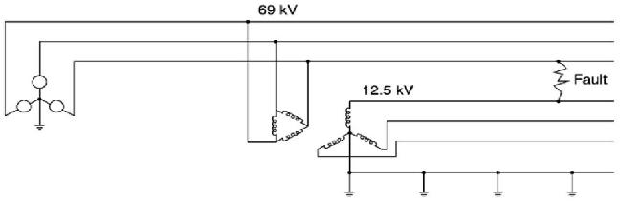

## Fig. 2.1.1.2: Fault from a Transmission Conductor to a Distribution Conductor [5]

Faults further from the distribution substation cause higher voltages, with the highest voltage at the fault location. Current flowing back towards the circuit causes a voltage rise along the circuit [5].

## Under voltage

Under voltage is defined as a sudden drop in the root mean square (r.m.s.) voltage and is usually characterized by the remaining (retained) voltage. Under voltage is thus, short duration reduction in r.m.s. voltage, caused mainly by short circuits, starting of large motors and equipment failures. Furthermore, under voltage may be classified by their duration as shown in

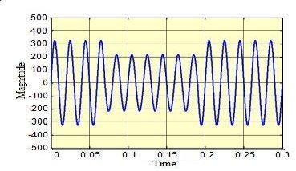

## Graph 2.2.1: Under voltage [1]

**Table 2.2.1: Classification of under voltage according to IEEE [1]**

|  |  |  |
| --- | --- | --- |
| Types of under  voltage | Duration | Magnitude |
| Instantaneous | 0.5 – 30 cycles | 0.1 – 0.9 pu |
| Momentary | 30 – 3 sec | 0.1 – 0.9 pu |
| Temporary | 3 sec – 1 min | 0.1 – 0.9 pu |

Under voltages are the most common power disturbance whose effect is quite severe especially in industrial and large commercial customers such as the damage of the sensitivity equipments and loss of daily productions and finances. The examples of the sensitive equipments are Programmable Logic Controller (PLC), Adjustable Speed Drive (ASD) and Chiller control. Under voltage at the equipment terminal can be due to a short circuit fault hundreds of kilometers away in the transmission system [1].

## Causes of Under voltage

There are various causes for which under voltages are created in system voltage [1].

* + - 1. **Closing and Opening of Circuit Breakers:** When the circuit breaker of a phase is opened suddenly, then the line which it is feeding will be temporarily disconnected. The other feeder lines from the same substation system will act as an under voltage.
      2. **Due to Fault:** Under voltage due to fault can be critical to the operation of a power plant. The magnitude of under voltage can be equal in each phase or unequal respectively and it depends on the nature of the fault whether it is symmetrical or unsymmetrical.
      3. **Due to Motor Starting:** Under voltage due to motor starting are symmetrical since the induction motors are balanced three phase loads, this will draw approximately the same high starting current in all the phases.
      4. **Due to Transformer Energizing:** There are mainly two causes of under voltage due to transformer energizing. One is normal system operations which include manual

energizing of a transformer and another is the reclosing actions. These under voltages are unsymmetrical in nature.

* + - 1. **Equipment Failure:** Failure of electrical equipment occurs due to insulation breakdown or heating or short circuit etc.
      2. **Bad Weather:** Lightning strikes in the power line cause a significant number of under voltages. A line to ground fault occurs when lightning strikes the line and continues to ground.
      3. **Pollution**: Flash over takes place when there is storm in the coastal regions, where the power line is covered with salt. This salt formation acts as a good conductor of electricity and faults occur.
      4. **Construction Activity:** Generally all power lines are undergrounded in urban areas, digging for doing foundation work of buildings can cause damage to underground cables and create under voltages.

## Power quality and its problem

According to Institute of Electrical and Electronic Engineers (IEEE) Recommended Practice for Monitoring Electric Power Quality,” IEEE Std. 1159-1995, June 1995, Power quality is defined as “The concept of powering and grounding sensitive electronic equipment in a manner suitable for the equipment”. In the last few decade power quality has become an important issue since many equipments are semiconductor based and controlling is done with power electronic equipments. All the equipments were heating, lighting and motors, which were not very sensitive to voltage variation. In the past the term reliability and quality was same as because there were no power electronic equipments and all the equipments were linear in nature Causes of Power Quality Problem.

Some common disturbances which may cause power quality problems are listed below:

1. Operation of non-linear and unbalanced loads.
2. Failure of equipment, e.g. transformers and cables.
3. Wrong maneuvers in distribution substations and plants.
4. Lightning and natural phenomena
5. Formation of snow on transmission line, storm etc.
6. Energization of capacitor banks and transformers.
7. Switching or start-up of large loads e.g. Induction motors.

In systems where overhead lines are predominant, natural phenomena are responsible for the majority of faults in transmission and distribution systems, especially lightning. In principle, alighting stroke is a transient increase in the voltage along the line. However, an arc is created between the phase hit by the stroke and ground and consequently the voltage is depressed to zero. When unbalanced loading is done on a system it causes an unbalance voltage in the phases, which ultimately creates power quality problem. This unbalance voltage increases rotor heating due to negative sequence magnetic flux generated in the stator winding. The main cause of power quality problem is the short circuit fault occurring in the distribution side. This short circuit can cause a huge increase in the system current and consequently a large voltage drop in the impedance of the supply system [3].

## Types of Load

1. **Resistive Load**

The design of hardware for resistive load is done by connecting a bulb of 50 Watt. The bulb glows in the limit of 150V to 230V. If the voltage goes down below 150V then it is a case of under voltage and if it exceeds 230V than it is a condition of over voltage. The limits of operating voltage can be changed using the two potentiometers connected in the hardware. . So the relay allows the supply voltage to be fed to the load [1].

## Capacitive Load

The design of hardware for capacitive load is done by connecting a capacitor of 2.50µF±5%. The LED glows in the limit of 148V to 200V. If the voltage goes down below 148V then it is a case of under voltage and if it exceeds 200V than it is a condition of over voltage.

The limits of operating voltage can be changed using the two potentiometers connected in the hardware [1]**.**

## Inductive Load

The design of hardware for inductive load is done by connecting a choke coil. The LED glows in the limit of 148V to 230V. If the voltage goes down below 148V then it is a case of under voltage and if it exceeds 230V than it is a condition of over voltage. The limits of operating voltage can be changed using the two potentiometers connected in the hardware [1].

## Introduction to Protection System

Over and under voltage protection circuit protects refrigerator, IM and other electrical appliances from abnormal voltage conditions. Our project aims to build system that monitors voltage and provides breakpoint based low and high voltage tripping mechanism that avoids any damage to the load, various industrial and domestic systems consist of fluctuation in the AC mains. In tripping system a quad comparator IC is used with two more comparator to be used as window comparator to it. When system deliver error the input voltage falls out of the window range. This trigger then operates a relay that cut off the load to avoid any damage to it. The lamp is used as load [7].

## Table 2.5.1: Different voltage condition [2]

|  |  |  |  |
| --- | --- | --- | --- |
| Condition | Voltage  Range | Operating  Voltage | Operation |
| Normal | 220 | 200 - 220 | Normal supply |
| 220 |
| 220 - 240 |
| Sag | 200 - 220 | 200 - 220 | Trip |
| Swell | 240 - 396 | 240 - 396 | Trip |
| Under Volt. | Below 220 | Below 220 | Trip |
| Over Volt. | Above 396 | Above 396 | Trip |

* + 1. **Application of Protection System**
       1. Industrial machinery
       2. House hold items like TV, refrigerator, AC
       3. Agriculture Motors
       4. Water pumps

## Advantages of Protection System

* + - 1. Highly sensitive
      2. Fit and Forget system
      3. Low cost and reliable circuit
      4. Complete elimination of manpower
      5. Can handle heavy loads up to 7A
      6. Auto switch OFF in abnormal conditions
      7. Auto switch ON in safe conditions

## Mitigation Techniques

This part consist of the about mitigation techniques over abnormal conditions like Overvoltage, under voltage, Sag and Swell.

## Controlled Ferroresonant Transformer

The controlled ferroresonant technology utilizes a special power transformer that employs a secondary tank circuit. The primary and secondary of this transformer are magnetically coupled through magnetic shunts. The amount of steel and air gap of these shunts controls the amount of magnetic coupling between the primary and secondary providing an inherent output current limiting.

The secondary of the ferroresonant transformer consists of a tank circuit that is resonated by a high voltage winding and capacitors. This tank circuit keeps the magnetic flux of the secondary in saturation. The effect of the saturated secondary is inherent voltage regulation (an open feedback loop regulator) and loads on the secondary are not linearly reflected back to primary. The primary presents an essentially resistive load to AC line.

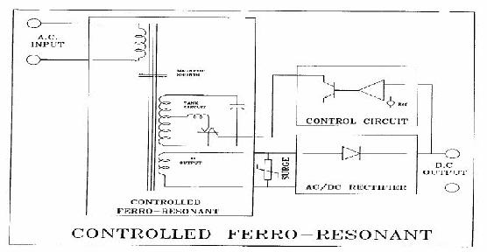

## Fig. 2.6.1: Controlled Ferroresonant Transformer Ckt Diagram [8]

The characteristics of a saturated secondary and physical separation between the primary and secondary windings in the power transformer design also provide excellent attenuation to incoming transient voltages that may be present on the AC. line. Metal Oxide Varistors are used in the La Marche ferroresonant product lines to provide additional protection for sensitive components on the DC side of the charger.

The typical efficiency of ferroresonant units with single phase AC. input is 75% and is approximately 85% for three phase inputs. The power factors for either input are typically over

0.9. Power factors that approach 1.0 usually indicate low input harmonic distortion. Although the power factor does not affect efficiencies, higher power factors lower the AC input current requirements [8].

## Automatic Voltage Regulator

In our practical life voltage may be high or low for purpose of electricity supply system or for the weakness of supply system or for other causes. For that reason, many important electric machine or electric equipment may destroy. In order to save these we need to use the voltage regulator. The voltage regulator may be manually or automatically controlled. The voltage can be regulated manually by tap-changing switches, a variable auto transformer, and an induction regulator. In manual control, the output voltage is sensed with a voltmeter connected at the output; the decision and correcting operation is made by a human being. The manual control may not always be feasible due to various factors and the accuracy, which can be obtained, depending on the degree of instrument and giving much better performance so far as stability. In modern large interconnected system, manual regulation is not feasible and therefore automatic voltage regulation equipment is installed on each generator [9].

## Coil Hold in Devices

Contactor coils are devices which have traditionally been susceptible to voltage sags. In some cases, the loss of a single contactor can lead to the loss of a whole production line even if all of the other equipment is immune to the voltage sag. A change to the contractor circuit or type can be a very simple and cost effective method of voltage sag mitigation. Coil hold-in devices are one such mitigation method. These devices are connected between the AC supply and the contactor and can generally allow a contactor to remain energized for voltage sags down to 25 % retained voltage [10].

## Uninterruptable Power Supply (UPS)

Uninterruptable power supplies (UPS) mitigate voltage sags by supplying the load using stored energy. Upon detection of voltage sag, the load is transferred from the mains supply to the UPS. Obviously, the capacity of load that can be supplied is directly proportional to the amount of energy storage available. UPS systems have the advantage that they can mitigate all voltage sags including outages for significant periods of time (depending on the size of the UPS).

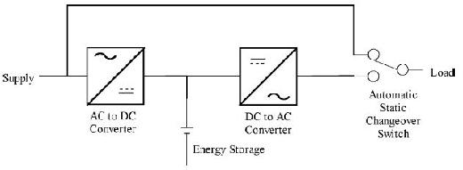

## Fig. 2.6.2: Block Diagram of Off-Line UPS [10]

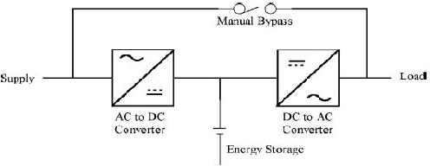

**Fig. 2.6.3: Block Diagram of On-Line UPS [10]**

There are 2 topologies of UPS available; on-line and off-line. Fig. 2.6.2 shows a schematic of an off-line UPS while Fig. 2.6.3 shows a schematic of an on-line UPS. Comparison of the figures shows that the difference between the two systems is that for an on-line UPS the load is always supplied by the UPS, while for off-line systems; the load is transferred from the mains supply to the UPS by a static changeover switch upon detection of voltage sag. The lack of a changeover switch renders the on-line system more reliable as any failure of the changeover switch will result in the off-line UPS being ineffective. UPS systems have disadvantages related to energy

storage components (mostly batteries) which must be maintained and replaced periodically. Small UPS systems are relatively simple and cheap. However, large units are complex and highly expensive due to the need for large energy storage capacities [10].

## Flywheel and Motor-Generator

Flywheel systems use the energy stored in the inertia of a rotating flywheel to mitigate voltage sags. In the most basic system, a flywheel is coupled in series with a motor and a generator which in turn is connected in series with the load. The flywheel is accelerated to a very high speed and when voltage sag occurs, the rotational energy of the decelerating flywheel is utilized to supply the load. Flywheel storage systems are effective for mitigation of all voltage sags including interruptions and can supply the load for a significant period of time (up to several seconds depending on the size of the flywheel). Fig. 2.6.4 shows the basic principle of the flywheel and motor-generator.

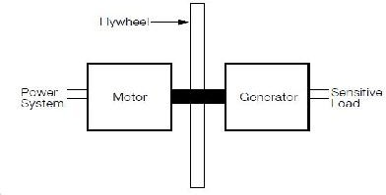

## Fig. 2.6.4: Basic Flywheel Motor Generator Configuration [11]

Flywheels have maintenance and reliability advantages over other energy storage systems such as batteries. However, if large energy storage capacities are required, flywheels must be large and are heavy. Further, the configuration shown in Fig. 2.6.4 will have high losses during normal operation. A number of solutions have been proposed to overcome this issue and most involve the inclusion of power electronics into the system. Such a solution is presented in Fig. 2.6.5. In this configuration, the motor which drives the flywheel is connected through a variable speed drive. This connection arrangement results in better starting characteristics for the flywheel and efficiency gains for the motor. Connection of the AC generator to a voltage source converter as shown increases the amount of energy that can be extracted from the flywheel due

to the fact that the converter is able to produce a constant DC voltage, which may then be used directly or converted back to AC voltage, over a wide speed range [11].

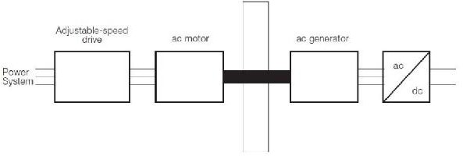

## Fig. 2.6.5: Impact of Sun Incidence Angle on Solar Cell Output [12]

1. **Dynamic Voltage Restorer (DVR)**

Dynamic Voltage Restorers (DVR) are complicated static devices which work by adding the ‘missing’ voltage during a voltage sag. Basically this means that the device injects voltage into the system in order to bring the voltage back up to the level required by the load. Injection of voltage is achieved by a switching system coupled with a transformer which is connected in series with the load. There are two types of DVRs available; those with and without energy storage. Devices without energy storage are able to correct the voltage waveform by drawing additional current from the supply. Devices with energy storage use the stored energy to correct the voltage waveform.

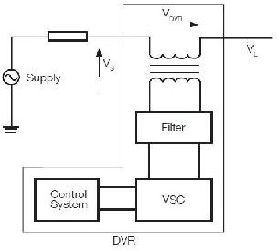

## Fig. 2.6.6: Block Diagram of DVR [13]

The difference between a DVR with storage and a UPS is that the DVR only supplies the part of the waveform that has been reduced due to the voltage sag, not the whole

waveform. In addition, DVRs generally cannot operate during interruptions. Fig. 2.6.6 shows a schematic of a DVR. As can be seen the basic DVR consists of an injection/booster transformer, a harmonic filter, a voltage source converter (VSC) and a control system [13].

## Static Var Compensator

A SVC is a shunt connected power electronics based device which works by injecting reactive current into the load, thereby supporting the voltage and mitigating the voltage sag. SVCs may or may not include energy storage, with those systems which include storage being capable of mitigating deeper and longer voltage sags. Fig. 2.6.7 shows a block diagram of a SVC [10].

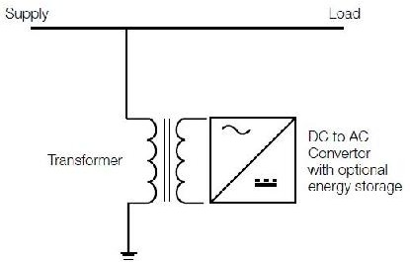

## Fig. 2.6.7: Block Diagram of SVC [10]

1. **Sag Proofing Transformers**

Sag proofing transformers, also known as voltage sag compensators, are basically a multi-winding transformer connected in series with the load. These devices use static switches to change the transformer turns ratio to compensate for the voltage sag. Sag proofing transformers are effective for voltage sags to approximately 40 % retained voltage. Fig. 2.6.8 shows a block diagram of a sag proofing transformer. Sag proofing transformers have the advantage of being basically maintenance free and do not have the problems associated with energy storage components. A disadvantage is that at this stage, sag proofing transformers are only available for relatively small loads of up to approximately 5 kVA. With the transformer connected in series, the system also adds to losses and any failure of the transformer will lead to an immediate loss of supply [14].

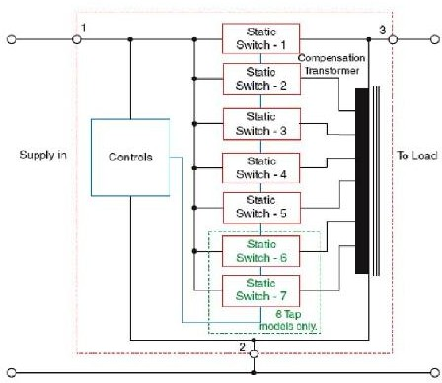

## Fig. 2.6.8: Block Diagram of Sag Proofing Transformer [14]

1. **Static Transfer Switch**

For facilities with a dual supply, one possible method of voltage sag mitigation is through the use of a static transfer switch. Upon detection of voltage sag, these devices can transfer the load from the normal supply feeder to the alternative supply feeder within half a cycle. The effectiveness of this switching operation is highly dependent on how independent of each other the 2 supply feeders are and the location of the event leading to the voltage sag.

Ideally, with a dual feeder supply, the 2 feeders should be supplied by different substations. Obviously, there are significant costs associated with dual supplies even if they are available [10].

# Chapter 3: System Description and Hardware Implementation

## Block Diagram

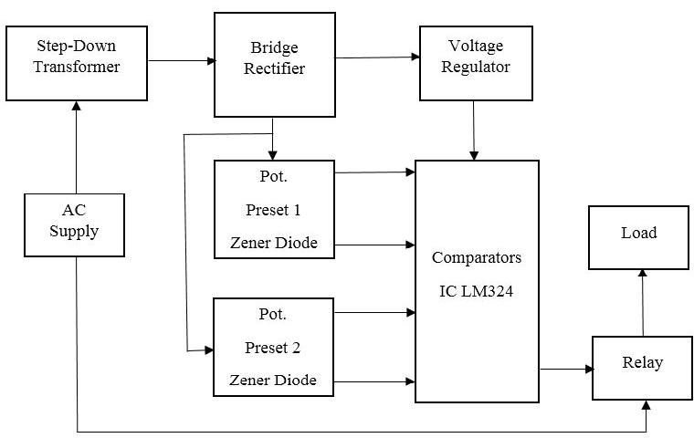

**Fig. 3.1.1: Block Diagram of Protection System [1]**

* 1. **Working**

AC supply is stepped down to 12 V by using a step down transformer. The AC supply is converted to DC supply through bridge rectifier. The supply is then filtered by capacitors connected across rectifier to reduce harmonics. Then the unregulated supply is then fed to voltage regulator whose output is given to the comparators IC LM324 and relay as supply. The unregulated supply from bridge rectifier is fed to preset 1 and preset 2 as input. The preset 1 and preset 2 are potentiometer ckt.1 and potentiometer ckt.2 respectively connected to comparators IC LM324 as command or input. The Preset conditions can be adjusted.

Further, the comparators are connected to the relay and load is connected to relay. Whenever there is overvoltage or under voltage the comparators analyze the preset conditions

and gives the signal to the relay and relay trips and the load get switched off. Thus protects the electrical appliance.

## Circuit Design

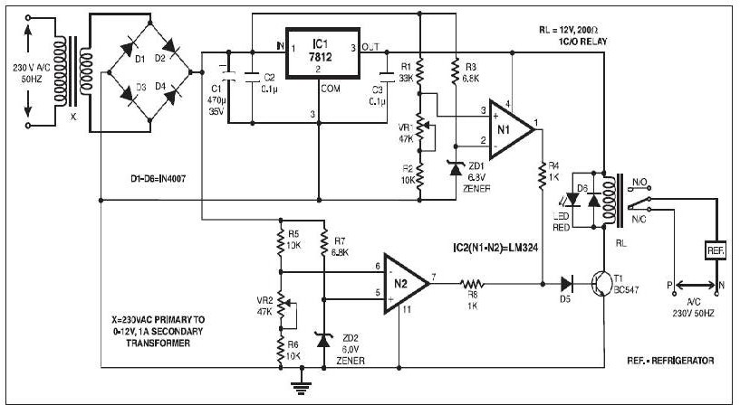

**Fig. 3.3.1: Circuit Diagram of Protection System [1]**

* 1. **Circuit Working Over Voltage Protection:**
     + Operational amplifier IC LM324 (IC2) is used here as a comparator. IC LM324 consists of four operational amplifiers, of which only two operational amplifiers (N1 and N2) are used in the circuit.
     + The unregulated power supply is connected to the series combination of resistors R1 and R2 and potentiometer VR1. The same supply is also connected to a 6.8V Zener diode (ZD1) through resistor R3.
     + Preset VR1 is adjusted such that for the normal supply of 180V to 240V, the voltage at the non-inverting terminal (pin 3) of operational amplifier N1 is less than 6.8V. Hence the output of the operational amplifier is zero and transistor T1 remains off.
     + The relay, which is connected to the collector of transistor T1, also remains de-energized. As the AC supply to the electrical appliances is given through the normally closed (N/C) terminal of the relay, the supply is not disconnected during normal operation.
     + When the AC voltage increases beyond 240V, the voltage at the non-inverting terminal (pin 3) of operational amplifier N1 increases. The voltage at the inverting terminal is still 6.8V because of the zener diode.
     + Thus now if the voltage at pin 3 of the operational amplifier is higher than 6.8V, the output of the operational amplifier goes high to drive transistor T1 and hence energize relay RL. Consequently, the AC supply is disconnected and electrical appliances turn off. Thus the appliances are protected against over-voltage.

## Under Voltage Protection:

* + - When the line voltage is below 180V, the voltage at the inverting terminal (pin 6) of operational amplifier N2 is less than the voltage at the non-inverting terminal (6V). Thus the output of operational amplifier N2 goes high and it energizes the relay through transistor T1. The AC supply is disconnected and electrical appliances turn off.
    - Thus the appliances are protected against under-voltage. IC1 is wired for a regulated 12V supply.
    - The relay energizes in two conditions: first, if the voltage at pin 3 of IC2 is above 6.8V, and second, if the voltage at pin 6 of IC2 is below 6V.
    - Over-voltage and under-voltage levels can be adjusted using presets VR1 and VR2, respectively.

## Hardware Implementation

It involves the details of the set of design specifications. The hardware design consists of, the selection of system components as per the requirement, the details of subsystems that are required for the complete implementation of the system has been carried out. It involves the component selection, component description and hardware details of the system designed.

1. Component selection and description.
2. Hardware details of the system designed.

## Component Selection and Description

Over voltage and under voltage tripping circuit design includes the following components:

* + - 1. TRANSFORMER - 230V, 50HZ
      2. DIODE BRIDGE RECTIFIER
      3. VOLTAGE REGULATOR - IC1 7812
      4. LM 324 (OPERATIONAL AMPLIFIER)
      5. ZENER DIODE
      6. RELAY
      7. POTENTIOMETER
      8. NPN TRANSISTOR
      9. CAPACITORS AND RESISTORS

## Hardware Details of the System

1. **Transformer:**
   * **Specification:**
     + Step down transformer 230V/12V
     + Operating frequency is 50HZ
     + Voltage is converted from 230 V to 12 V
     + Current rating is 1A.

Low voltage power is described as power supplied from a transformer of 30 volts or less. The transformer actually steps down and converts 230 volt power to 30 volts or less. Transformers are normally mounted on a junction box. Sometimes transformers have more than one voltage connection point, called a multi-tap transformer.

Transformers are constructed of two tightly wound coils encased in a metal cover. Since the two coils are placed closely together in the case, current flows through the primary winding (the 120-volt side) and as it does this, it produces a magnetic flow. This flow produces current in the second coil winding (secondary winding) that produces the low voltage output.

The primary coil has more windings than the secondary coil. Because of the reduced number of windings in the secondary coil, the voltage output is much less. Secondary windings

usually produce voltages between 8 and 24 volts.An electronic low contains an electronic device, called an inverter, which allows the

voltage transformer also size of the low voltage

transformer to be substantially smaller. An inverter and a small transformer make up the main components of what we normally call an electronic low voltage transformer.

## Characteristics:

* + - Used for indoors
    - Low voltage ripple noise
    - Green energy saving chip
    - Design double insulated

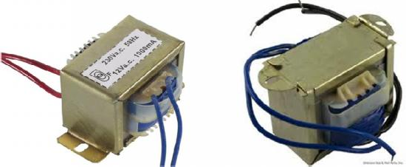

## Fig. 3.5.2.1: Low Voltage Step down Transformer

1. **Diode Bridge Rectifier:**

A diode bridge is a device that changes Alternating Current (AC) to Direct Current (DC). A diode bridge is an arrangement of four (or more) diodes in a bridge configuration that provides the same polarity of output for either polarity of input. When used in its most common application, for conversion of an alternating current (AC) input into direct current a (DC) output, it is known as a bridge rectifier. A bridge rectifier provides full-wave rectification from a two- wire AC input, resulting in lower cost and weight as compared to a rectifier with a 3-wire input from a transformer with a center-tapped secondary winding. The essential feature of a diode bridge is that the polarity of the output is the same regardless of the polarity at the input.

According to the conventional model of current flow originally established by Benjamin Franklin and still followed by most engineers today, current is assumed to flow through electrical conductors from the positive to the negative pole. In actuality, free electrons in a conductor nearly always flow from the negative to the positive pole. In the vast majority of applications, however, the actual direction of current flow is irrelevant. Therefore, in the discussion below the conventional model is retained. In the diagrams below, when the input connected to the left corner of the diamond is positive, and the input connected to the right corner is negative, current flows from the upper supply terminal to the right along the red (positive) path to the output, and returns to the lower supply terminal via the blue (negative) path.

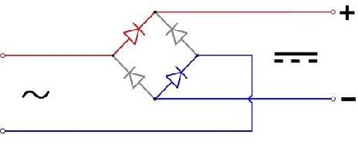

## Fig. 3.5.2.2: Bridge Rectifier (positive half cycle)

When the input connected to the left corner is negative, and the input connected to the right corner is positive, current flows from the lower supply terminal to the right along the

red (positive) path to the output, and returns to the upper supply terminal via the blue (negative) path.

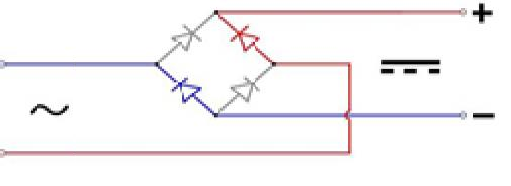

## Fig. 3.5.2.3: Bridge Rectifier (negative half cycle)

In each case, the upper right output remains positive and lower right output negative. Since this is true whether the input is AC or DC, this circuit not only produces a DC output from an AC input, it can also provide what is sometimes called "reverse polarity protection". That is, it permits normal functioning of DC-powered equipment when batteries have been installed backwards, or when the leads (wires) from a DC power source have been reversed, and protects the equipment from potential damage caused by reverse polarity. Prior to the availability of integrated circuits, a bridge rectifier was constructed from "discrete components", i.e., separate diodes. Since about 1950, a single four-terminal component containing the four diodes

connected in a bridge configuration became a standard commercial available with various voltage and current ratings.

component and is now

## Voltage Regulator – IC LM7812

* + **Specification:**
    - Output current in excess of 1A.
    - Output Voltages of 12V.
    - Current internal thermal overload protection.
    - No external components required.
    - Output transistor safe area protection.
    - Internal short circuit limit.

## Theory:

A voltage regulator is an electrical regulator designed to automatically maintain a

constant voltage level. A voltage regulator is an example of a negative feedback control loop. It may use an electromechanical mechanism, or electronic components. Depending on the design, it may be used to regulate one or more AC or DC voltages.

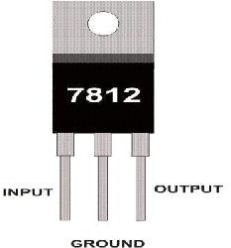

## Fig. 3.5.2.4: IC 7812

Electronic voltage regulators operate by comparing the actual output voltage to some internal fixed reference voltage. Any difference is amplified and used to control the regulation element in such a way as to reduce the voltage error. This forms a negative feedback control loop; increasing the open-loop gain tends to increase regulation accuracy but reduce stability (avoidance of oscillation, or ringing during step changes). There will also be a trade-off between stability and the speed of the response to changes. If the output voltage is too low (perhaps due to input voltage reducing or load current increasing), the regulation element is commanded, up to a point, to produce a higher output voltage - by dropping less of the input voltage (for linear series regulators and buck switching regulators), or to draw input current for longer periods (boost-type switching regulators); if the output voltage is too high, the regulation element will normally be commanded to produce a lower voltage. However, many regulators have over-current protection, so that they will entirely stop sourcing current (or limit the current in some way) if the output current is too high, and some regulators may also shut down if the input voltage is outside a given range.

## IC LM324

* + **Specifications:**
    - Internally frequency compensated for unity gain
    - Large DC voltage gain 100 dB
    - Wide bandwidth (unity gain) 1 MHz
    - Wide power supply range
    - Very supply current drain (700 µA)
    - Low input biasing current 45 mA (temperature compensated)
    - Low input offset voltage 2 mV and offset current 5 mA
    - Input common mode voltage range includes ground

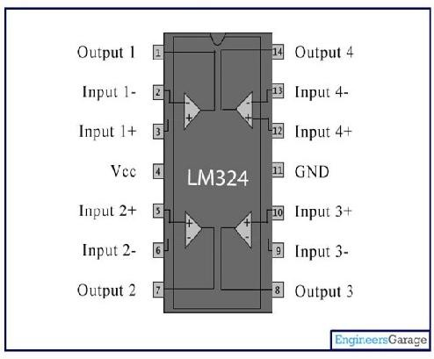

## Fig 3.5.2.5 Pin Configuration LM 324

**Table 3.5.2.1: Pin Description of LM324**

|  |  |  |
| --- | --- | --- |
| Pin No. | Function | Name |
| 1 | Output of 1st comparator | Output1 |
| 2 | Inverting input of 1st comparator | Input1- |
| 3 | Non-inverting input of 1st comparator | Input1+ |
| 4 | Supplyvoltage;5V(upto32V) | Vcc |
| 5 | Non-inverting input of 2nd comparator | Input2+ |
| 6 | Inverting input of 2nd comparator | Input2- |
| 7 | Output of 2nd comparator | Output2 |
| 8 | Output of 3rd comparator | Output3 |
| 9 | Inverting input of 3rd comparator | Input3- |
| 10 | Non-inverting input of 3rd comparator | Input3+ |
| 11 | Ground(0V) | Ground |
| 12 | Non-inverting input of 4th comparator | Input4+ |
| 13 | Inverting input of 4th comparator | Input4- |
| 14 | Output of 4th comparator | Output4 |

The LM324 series consists of four independent, high gains; internally frequency compensated operational amplifiers which were designed specifically to operate from a single power supply over a wide range of voltages. Operation from split power supplies is also possible and the low power supply current drain is independent of the magnitude of the power supply voltage.

## Zener Diode

A Zener diode is a type of diode that permits current not only in the forward direction like a normal diode, but also in the reverse direction if the voltage is larger than the breakdown voltage known as "Zener knee voltage" or "Zener voltage".

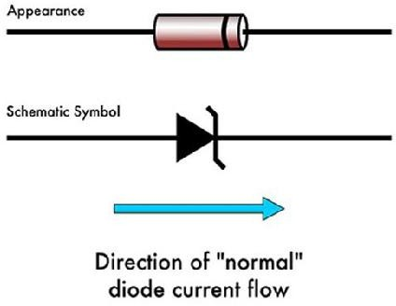

## Fig. 3.5.2.6: Zener Diode

A conventional solid-state diode will not allow significant current if it is reverse-biased below its reverse breakdown voltage. When the reverse bias breakdown voltage is exceeded, a conventional diode is subject to high current due to avalanche breakdown. Unless this current is limited by circuitry, the diode will be permanently damaged. In case of large forward bias (current in the direction of the arrow), the diode exhibits a voltage drop due to its junction built- in voltage and internal resistance. The amount of the voltage drop depends on the semiconductor material and the doping concentrations.

A Zener diode exhibits almost the same properties, except the device is specially designed so as to have a greatly reduced breakdown voltage, the so-called Zener voltage. By contrast with the conventional device, a reverse-biased Zener diode will exhibit a controlled breakdown and allow the current to keep the voltage across the Zener diode at the Zener voltage. For example, a diode with a Zener breakdown voltage of 3.2 V will exhibit a voltage drop of 3.2

V if reverse bias voltage applied across it is more than its Zener voltage. The Zener diode is therefore ideal for applications such as the generation of a reference voltage (e.g. for an amplifier stage), or as a voltage stabilizer for low-current applications.

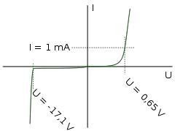

## Fig. 3.5.2.7: Characteristic curve of Zener Diode

1. **Relay**

A relay is an electrically operated switch. Many relays use an electromagnet to operate a switching mechanism mechanically, but other operating principles are also used. Relays are used where it is necessary to control a circuit by a low-power signal (with complete electrical isolation between control and controlled circuits), or where several circuits must be controlled by one signal

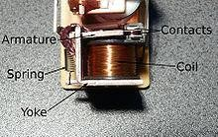

## Fig. 3.5.2.8: Relay

A simple electromagnetic relay consists of a coil of wire surrounding a soft iron core, an iron yoke which provides a low reluctance path for magnetic flux, a movable iron

armature, and one or more sets of contacts (there are two in the relay pictured). The armature is hinged to the yoke and mechanically linked to one or more sets of moving contacts. It is held in place by a spring so that when the relay is de-energized there is an air gap in the magnetic circuit. In this condition, one of the two sets of contacts in the relay pictured is closed, and the other set is open. Other relays may have more or fewer sets of contacts depending on their function. The relay in the picture also has a wire connecting the armature to the yoke. This ensures continuity of the circuit between the moving contacts on the armature, and the circuit track on the printed circuit board (PCB) via the yoke, which is soldered to the PCB.

When an electric current is passed through the coil it generates a magnetic field that attracts the armature and the consequent movement of the movable contact either makes or breaks (depending upon construction) a connection with a fixed contact. If the set of contacts was closed when the relay was de-energized, then the movement opens the contacts and breaks the connection, and vice versa if the contacts were open. When the current to the coil is switched off, the armature is returned by a force, approximately half as strong as the magnetic force, to its relaxed position. Usually this force is provided by a spring, but gravity is also used commonly in industrial motor starters. Most relays are manufactured to operate quickly. In a low-voltage application this reduces noise; in a high voltage or current application it reduces arcing.

When the coil is energized with direct current, a diode is often placed across the coil to dissipate the energy from the collapsing magnetic field at deactivation, which would otherwise generate a voltage spike dangerous to semiconductor circuit components. Some automotive relays include a diode inside the relay case. Alternatively, a contact protection network consisting of a capacitor and resistor in series (snubber circuit) may absorb the surge. If the coil is designed to be energized with alternating current (AC), a small copper "shading ring" can be crimped to the end of the solenoid, creating a small out-of-phase current which increases the minimum pull on the armature during the AC cycle.

A solid-state relay uses a thyristor or other solid-state switching device, activated by the control signal, to switch the controlled load, instead of a solenoid. An optocoupler (a light-

emitting diode (LED) coupled with a photo transistor) can be used to isolate control and controlled circuits.

## Potentiometer

A potentiometer (colloquially known as a "pot") is a three- terminal resistor with a sliding contact that forms an adjustable voltage divider. If only two terminals are used (one side and the wiper), it acts as a variable resistor or rheostat. Potentiometers are commonly used to control electrical devices such as volume controls on audio equipment. Potentiometers operated by a mechanism can be used as position transducers, for example, in a joystick.

Potentiometers are rarely used to directly control significant power (more than a watt), since the power dissipated in the potentiometer would be comparable to the power in the controlled load. Instead they are used to adjust the level of analog signals (e.g. volume controls on audio equipment), and as control inputs for electronic circuits. For example, a light dimmer uses a potentiometer to control the switching of a TRIAC and so indirectly control the brightness of lamps.

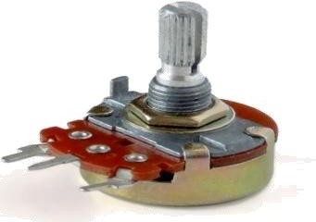

## Fig. 3.5.2.9: Potentiometer

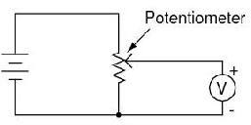

**Fig. 3.5.3.0: Schematic Diagram of Potentiometer**

1. **Transistor**

A transistor is a semiconductor device used to amplify and switch electronic signals and electrical power. It is composed of semiconductor material with at least three terminals for connection to an external circuit. A voltage or current applied to one pair of the transistor's terminals changes the current through another pair of terminals. Because the controlled (output) power can be higher than the controlling (input) power, a transistor can amplify a signal. Today, some transistors are packaged individually, but many more are found embedded in integrated circuits.

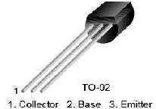

## Fig. 3.5.3.1: Transistor

**Table 3.5.2.2: Absolute Maximum Ratings of Transistor**

|  |  |  |  |
| --- | --- | --- | --- |
| **Symbol** | **Parameter** | **Value** | **Units** |
| VCBO | Collector bas vtg. :BC547 | 50 | V |
| VCEO | Collector Emitter vtg. | 45 | V |
| VEBO | Emitter Base vtg. | 6 | V |
| IC | Collector Current(DC) | 100 | mA |
| PC | Collector Power Dissp. | 500 | mW |
| TJ | Junction Temperature | 150 | ˚C |
| TSTG | Storage Temperature | -65 ~ 150 | ˚C |

1. 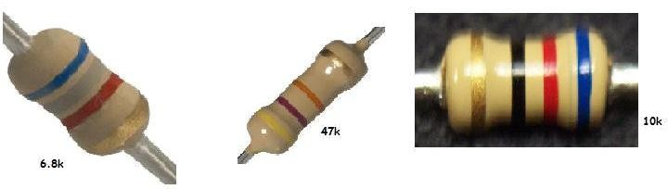**Capacitors and Resistors Used Resistors:**

**Fig. 3.5.3.2: Resistors Table 3.5.2.3: Resistors Used**

|  |  |
| --- | --- |
| **Rating of Resistor** | **Required Numbers** |
| 33 kΩ | 1 |
| 6.8 kΩ | 2 |
| 10 kΩ | 2 |
| 1 kΩ | 2 |

**Capacitors:**

Capacitor stores and release electrical charge. They are used for filtering power supply lines, tuning resonant circuits, and for blocking DC voltages while passing AC signals, among numerous other uses.

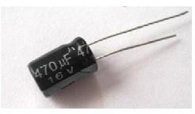

## Fig. 3.5.3.3: Capacitor 470 µF

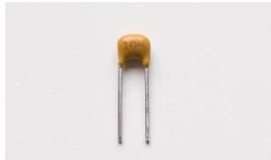

**Fig.3.5.3.4: Capacitor 0.1 µF Table 3.5.2.4: Capacitors Used**

|  |  |
| --- | --- |
| **Rating of Capacitor** | **Required Numbers** |
| 470 µF | 1 |
| 0.1 µF | 2 |

**Chapter 4: Discussion and Result**

* 1. **Discussion**

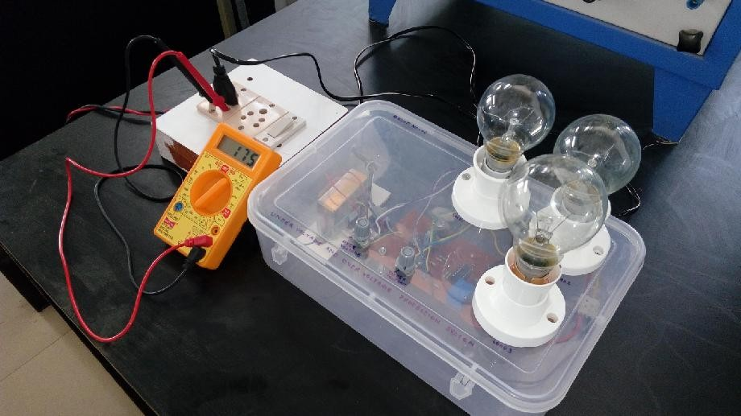

**Fig. 4.1.3.1: Circuit Implementation**

The above picture shows implemented Under Voltage and Over Voltage Protection System. The system is fitted in acrylic box for resistive load of three lamps. Three lamps are connected in parallel as our load is always connected in parallel for constant and same voltage in household, commercial and industrial places. Both system and load getting same A.C. supply from the autotransformer to demonstrate how system responds to under voltage and over voltage condition created by autotransformer at that time.

The two potentiometer are mounted on box to vary the range of normal supply.

Above picture depicts that system is worked in under voltage condition.

## Results

**Normal Voltage Supply:**

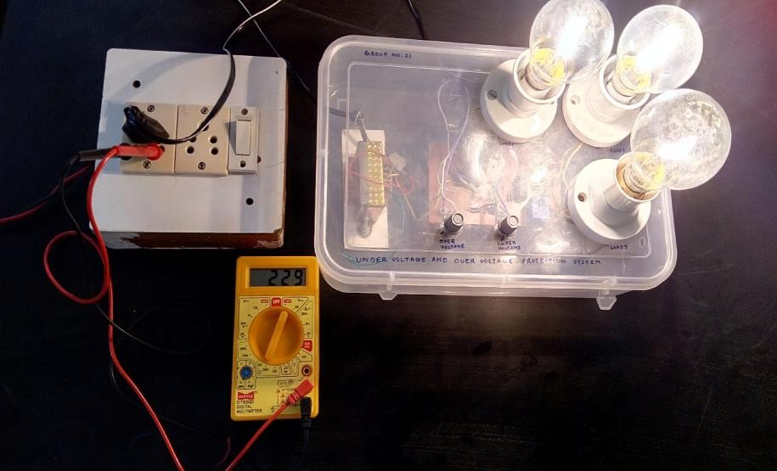

**Fig. 4.2.1: Normal Voltage Supply**

By using two potentiometer normal supply range is selected between 180 V to 250

V. The supply voltage as shown by multimeter in above picture is 229 Volt, hence the protection circuit is closed at that time and the load is switched ON.

Here protection circuit closed means the normally open contact of relay get closed when normal supply is sensed by the protection circuit. The three lamps connected as load are of different watt that is 40 watt, 60 watt and 100 watt.

So for any prescribed range of voltage selected by two potentiometer, the protection circuit remain closed and load is ON. Normally all household appliances have 230 V voltage rating.

## Under Voltage Supply:

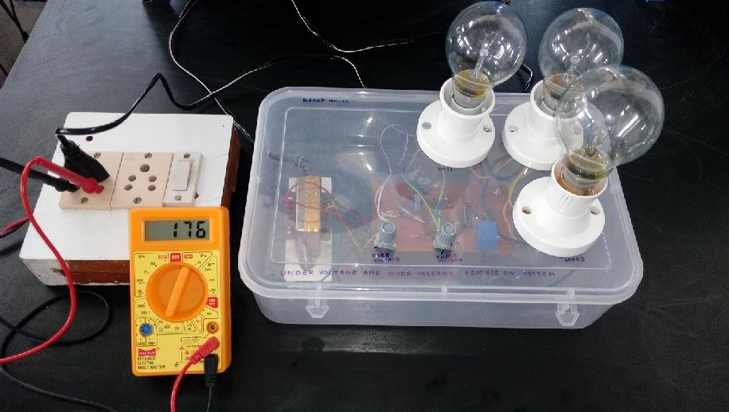

**Fig. 4.2.2: Under Voltage Supply**

When the supply voltage is below 180 V, the comparator IC LM324 checks the voltage at the inverting terminal (pin 6) of operational amplifier N2 is less than the voltage at non-inverting terminal (6V). Thus the output of operational amplifier goes high and it energizes the relay.

When relay is get energized the protection circuit act as open circuit and it disconnect the AC supply and load get off. The Above picture depicts the working of protection circuit in under voltage supply and under voltage reading recorded by multimeter is 176 V.

Thus, when there is under voltage, the protection circuit automatically switched off the load and protects the load.

## Over Voltage Supply:

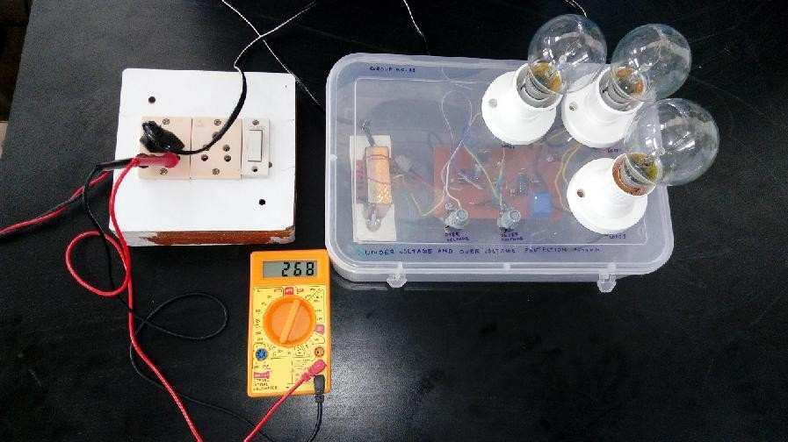

**Fig. 4.2.3: Over Voltage Supply**

The over voltage limit is selected by the variable resistor 2 i.e. potentiometer 2. So, the beyond 250 voltage level the protection circuit will remain open and load is off.

When the line voltage increases above 250 V, the comparator IC check the voltage at the non-inverting terminal (pin 3) of operational amplifier increases and the voltage at inverting terminal remain same 6.8V due to zener diode. Thus output of operational amplifier goes high and relay get energized through transistor. As the relay get energized the AC supply get disconnected and load is turned off.

Thus, load is protected from over voltage and reading recorded by multimeter is

268 V.

# Chapter 5: Conclusions

## Conclusion

The protection circuit can be used to protect the costly electrical appliances from abnormal conditions like sag, swell, under voltage and overvoltage and avoid appliances being effected from harmful effects.

## Future Scope

If we control the tap changing transformer automatically then we can operate the load normally in under voltage and over voltage condition. Hence we can protect as well as operate the load in abnormal voltage.

This System can be later improved by integrating it with GSM modem that alerts user by sending an SMS about the tripping occurred.

# References

1. Article, “Over voltage Under voltage load Protection”, website: <http://www.nevonprojects.com/Over-voltage-Under-voltage-load-protection.html>, last Accessed 27 September 2015.
2. Endeavour Energy Power Quality & Reliability Centre, “Voltage Sag Mitigation”,

Technical Note 11, August 2012.

1. All about Circuits, Voltage Regulation, Available from: [http://www.allaboutcircuits.com/vol_2/chpt_9/6.html,](http://www.allaboutcircuits.com/vol_2/chpt_9/6.html) last Accessed 29 September 2015
2. Sag Proofing Technologies Inc, Installation and Service Manual - Voltage-Sag Compensators, 2005.

# Appendix

## Data Sheets:

**Capacitors (Electrolytic LPR series):**

Features:

* + Material: Aluminium.
  + Large size snap-In.
  + LPR series large size capacitors with the specially designed terminals have "self- standing" and can be directly soldered to printed circuit boards without holders.
  + They are easily to fixing to printed circuit boards due to the specially designed terminals.

Specification Table:

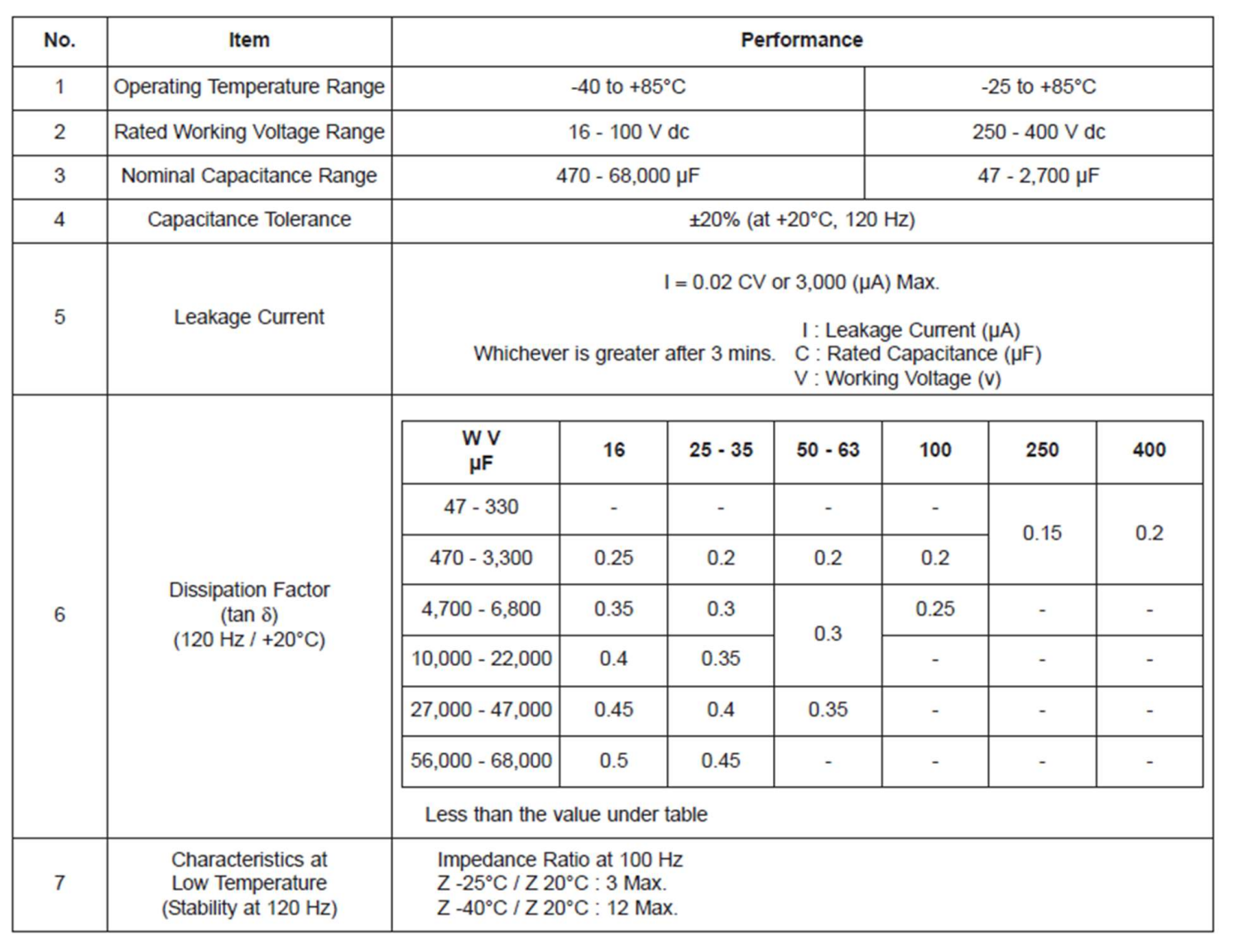

Specification Table:

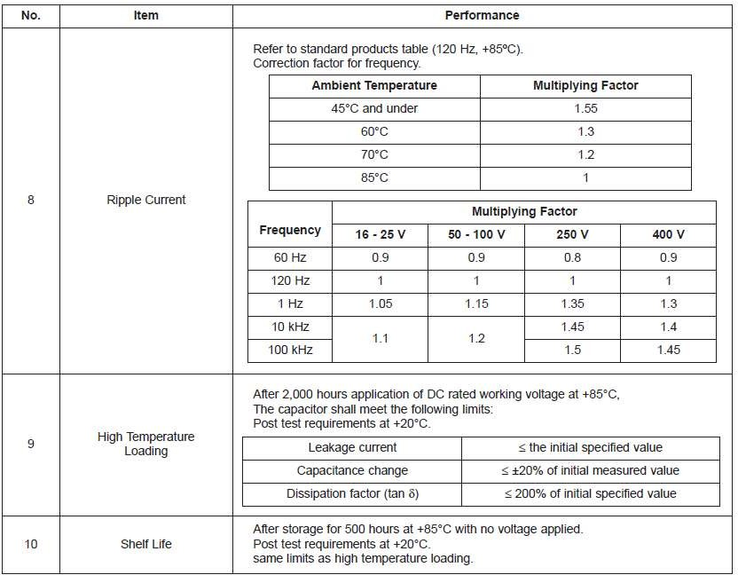

Diagram of Dimensions:

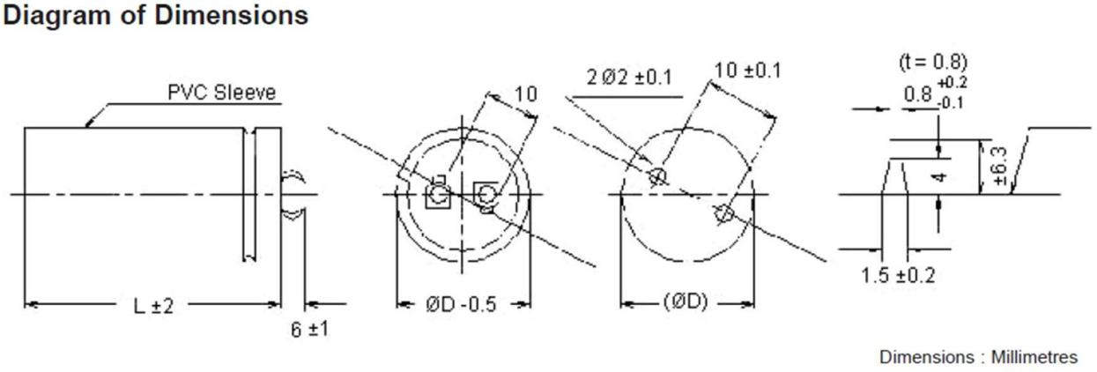

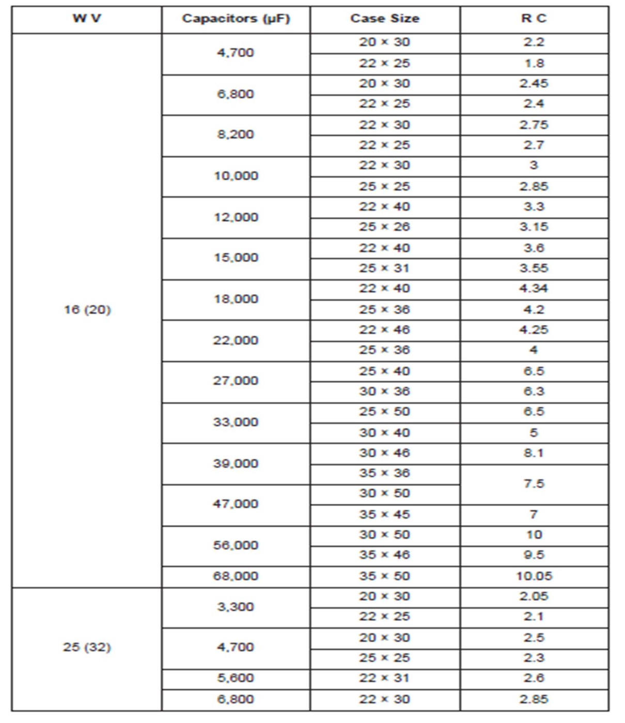

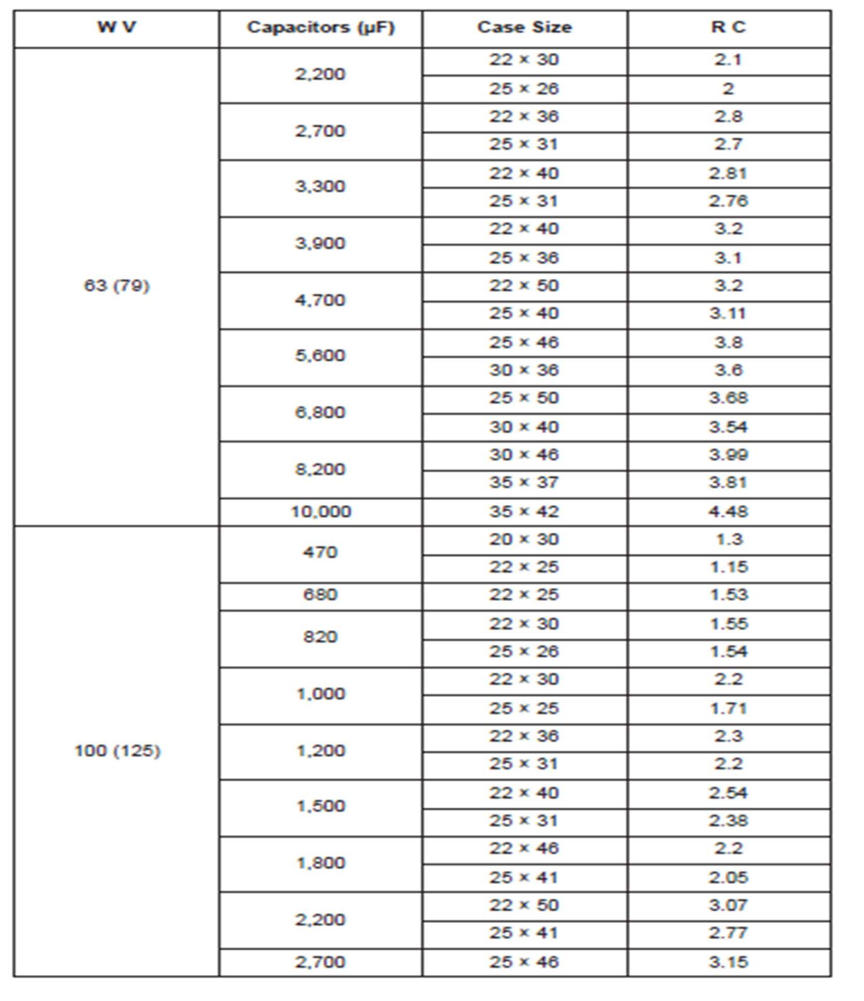

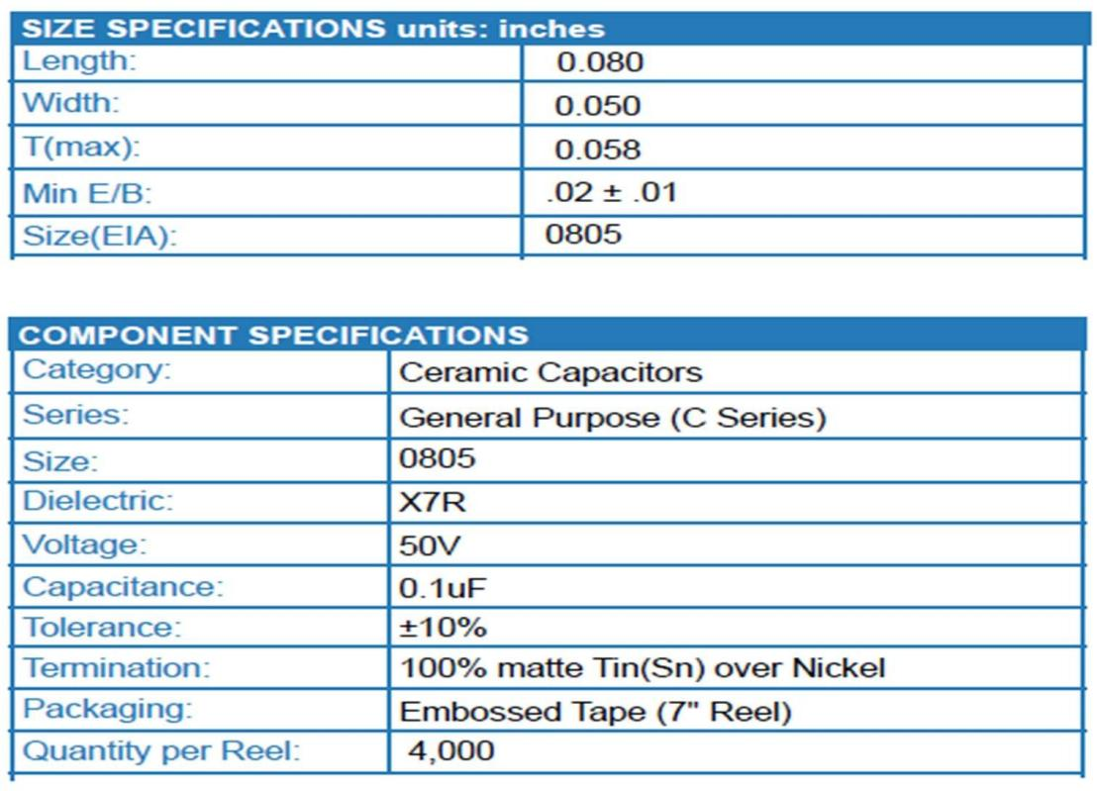

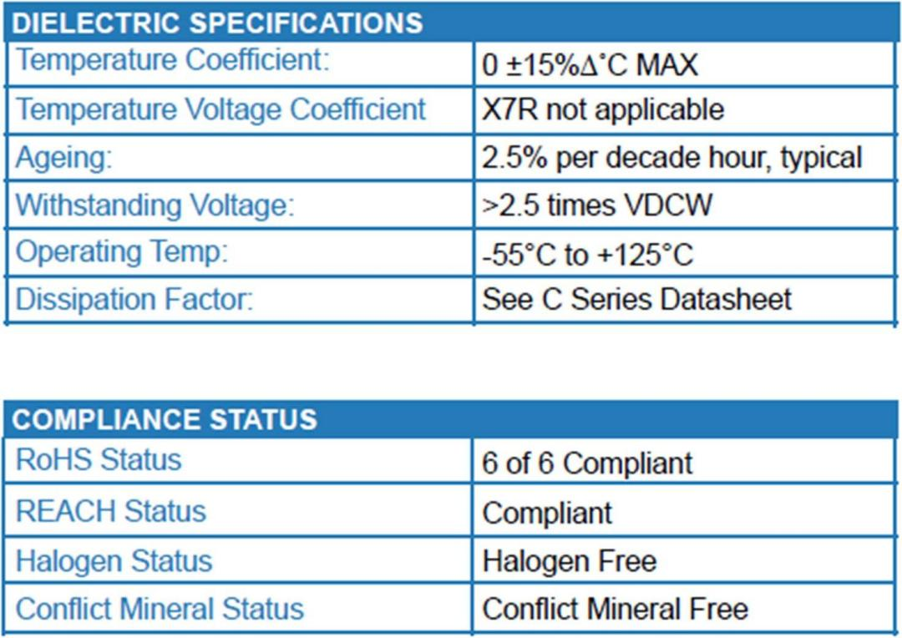

Single Supply Quad Operational Amplifiers

The LM324 series are low−cost, quad operational amplifiers with true differential inputs. They have several distinct advantages over standard operational amplifier types in single supply applications. The quad amplifier can operate at supply voltages as low as 3.0 V or as high as 32 V with quiescent currents about one−fifth of those associated with the MC1741 (on a per amplifier basis). The common mode input range includes the negative supply, thereby eliminating the necessity for external biasing components in many applications. The output voltage range also includes the negative power supply voltage.

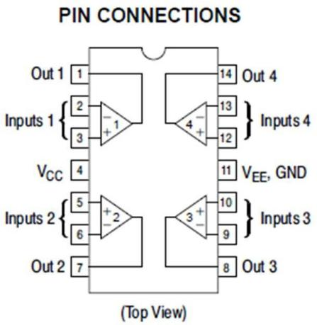Features:

* + Short Circuited Protected Outputs
  + True Differential Input Stage
  + Single Supply Operation: 3.0 V to 32 V
  + Low Input Bias Currents: 100 nA Maximum (LM324A)
  + Four Amplifiers Per Package
  + Internally Compensated
  + Common Mode Range Extends to Negative Supply
  + Industry Standard Pinouts
  + ESD Clamps on the Inputs Increase Ruggedness without Affecting Device Operation
  + NCV Prefix for Automotive and Other Applications Requiring Unique Site and Control Change Requirements; AEC−Q100
  + Qualified and PPAP Capable Circuit Description:

The LM324 series is made using four internally compensated, two−stage operational amplifiers. The first stage of each consists of differential input devices Q20 and Q18 with input buffer transistors Q21 and Q17 and the differential to single ended converter Q3 and Q4. The first stage performs not only the first stage gain function but also performs the level shifting and transconductance reduction functions. By reducing the transconductance, a smaller compensation

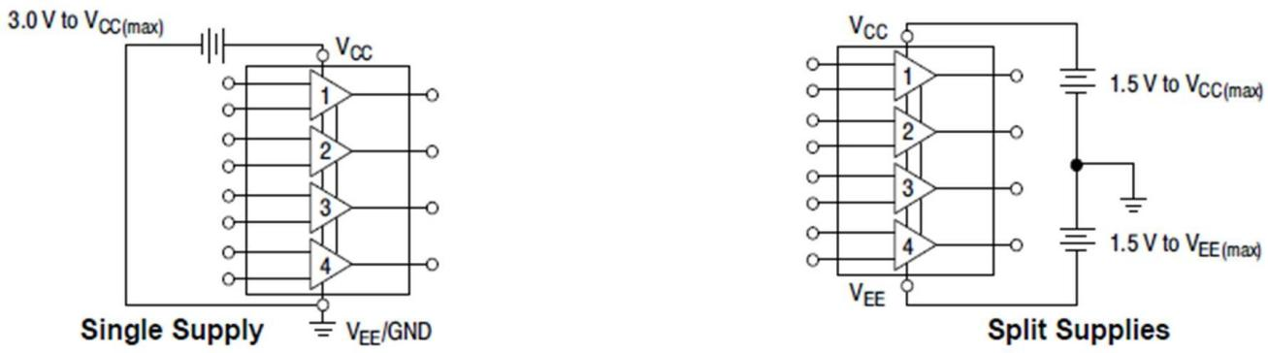

capacitor (only 5.0 pF) can be employed, thus saving chip area. The transconductance reduction is accomplished by splitting the collectors of Q20 and Q18.Another feature of this input stage is that the input common mode range can include the negative supply or ground, in single supply operation, without saturating either the input devices or the differential to single−ended converter. The second stage consists of a standard current source load amplifier stage.

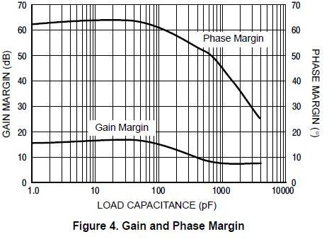

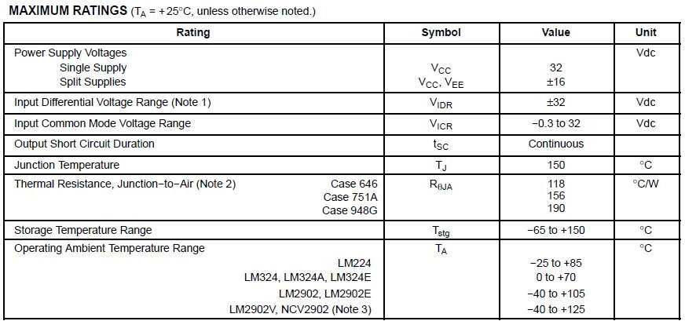

## ESD Ratings:

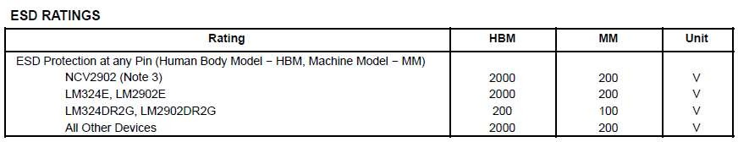

**1N4007:**

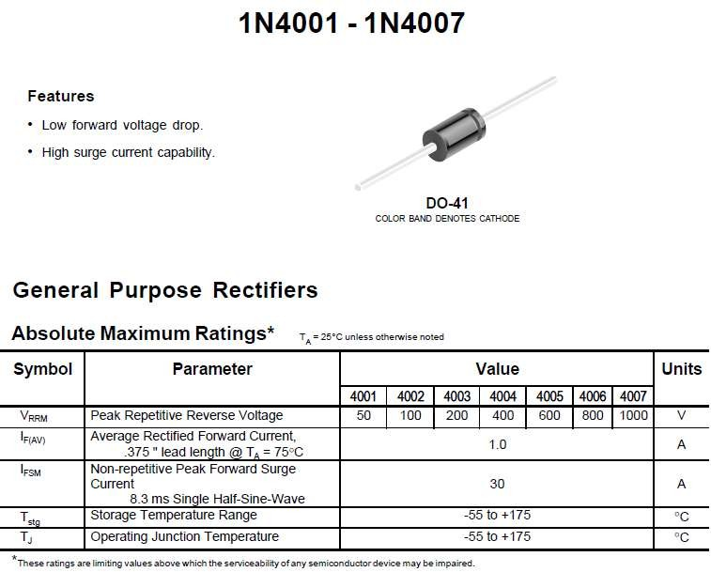

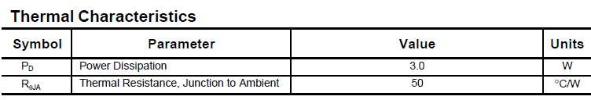

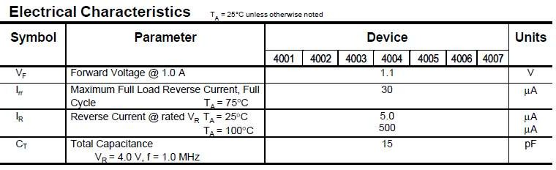

**Typical Characteristics:**

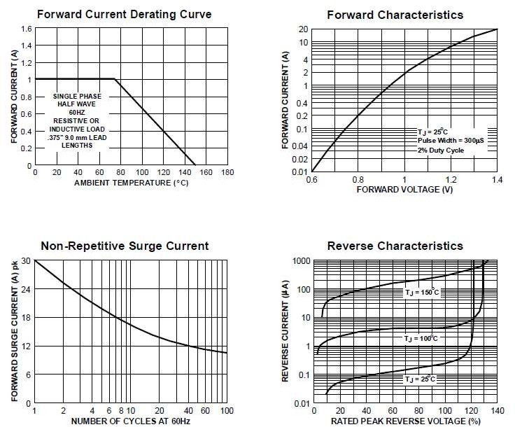

**Potentiometer:**

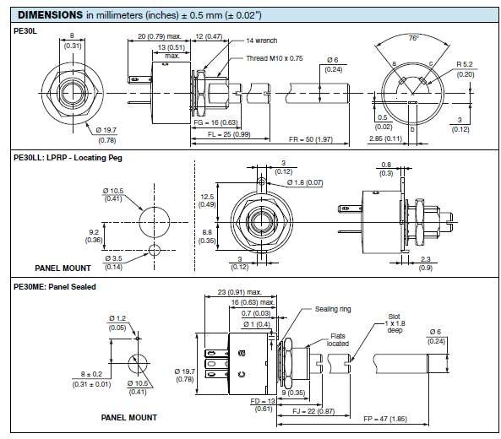

Fully Sealed Potentiometer:

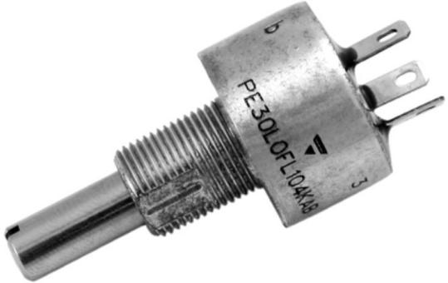

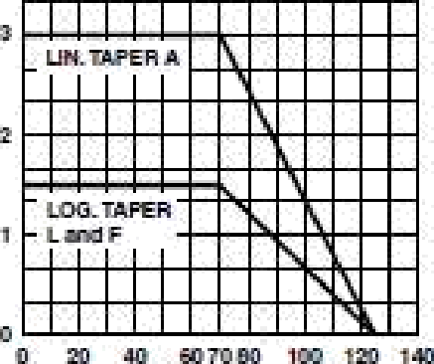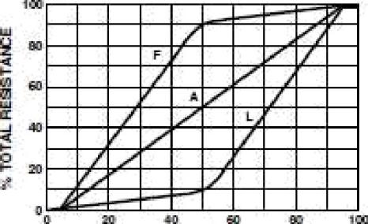

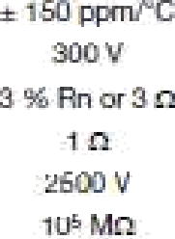

Indeper<Ieu Ideally !rygicaI}

Insular+zo resistance l• *1

Dielectric strength (F¥dS}

End resistance ,fypicafj

Lizziling elern•am voltage

j

Tempeewe cceffickot

Power ra£ing

Taper

Tolerance

1 - 2£ - a.7 and cv request 1 - 2 - 5

l2andad series E3

ICO rt to 2.2

Z7O'* tT

G

Flasiatc'e eIe¥x'ent

ELECTFTICAL BDECfF CATIONS

|  |  |  |  |  |  |  |
| --- | --- | --- | --- | --- | --- | --- |
| STANDARD RESISTANCE ELEMENT DATA | | | | | | |
|  |  | | | LOGS TAPER | | |
|  |  | MAX. CUR. THROUGH WIPER | fdAX. POVVER ATT0’C | MAX. WORKI NG VOLTAGE | MAX. CUR. THROUGH WIPER |
|  | W | V | mA |  | V | mA |
| 47  1D0  220  470  1K  2.2K  4y  10K  22K  47K  100K  220K  70K IM    4.7M  10M | 3  3  3  3  3  3  3  3  3  3  1.91  0.90  0.41  0.19  0.09  0.D4  0.02  0.01 | B.1 11.9  17.3  25.7  37.5  54.8  81.2  119.9  173  257.7  300  300  300  30D  300  30D  300  300 | 369  252  173  116  yg  54  37    17    6.3  3  ].36  0.63  0.30  0.43  0.06  0.03 | 1.5  1.5  1.5  1.5    1.5  1.5  1.5  1.5  0.9  0.41  0.19    0.04 | 1 2.2  18.2  26.6  38.7  57.4  83.9  122  181.6  265  300  300  300  300  300 | 1 22  82.6  56.6  38.7  26.1  17.9    8.25  5.64    1.36  0.63  0.Z0  0.13 |

## Relay:

A Power Relay with various models

* + High-sensitivity (250 mW) and High-capacity (16 A) versions.
  + 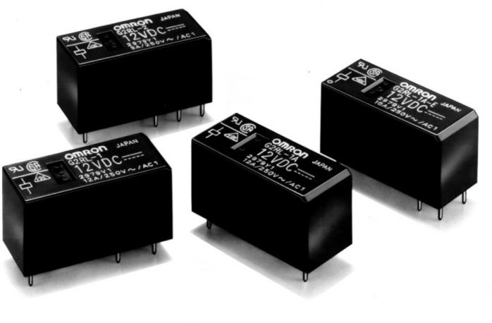Designed for cooking and HVAC controls: blower motor, damper, active air purification, duct flow boost fans, etc.
  + Conforms to VDE (EN61810-1). UL recognized/ CSA certified
  + Meets EN60335-1 requirements for household products.
  + Clearance and creep age distance: 10 mm/10 mm.
  + Tracking resistance: CTI>250
  + Coil Insulation system: Class F.
  + 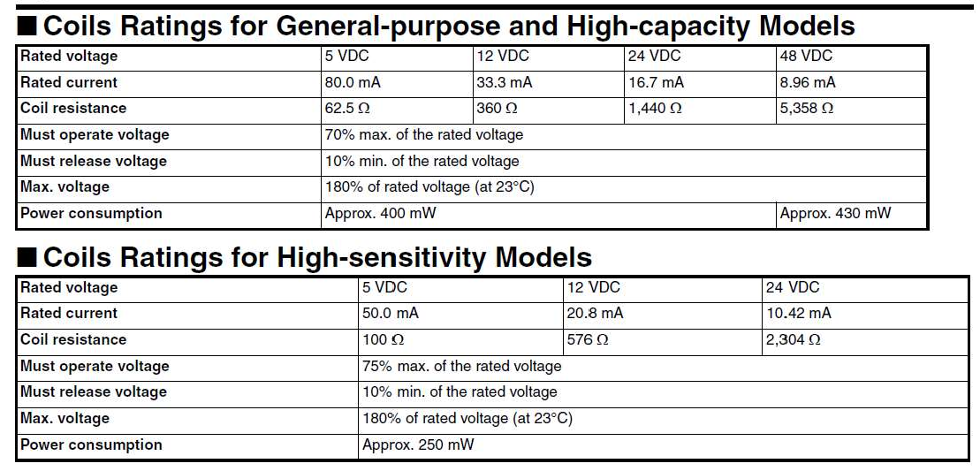RoHS Compliant Specifications:
* Contact Ratings

|  |  |  |  |  |
| --- | --- | --- | --- | --- |
| Item | General-purpose Models | | High-capacity ModeJs | High-sensitivity Models |
| Number of poles | 1 pole | 2 poles | 1 pole | 1 pole |
| Contact material | Ag Alloy (Cd free) | | | |
| Load | Resistive road (cose=1 ) | | | |
| Rated load | 2 A at 250 VAC  2 A at 24 VDC  (See note.) | 8 A at 250 VAC  B A at 30 VDC  (See note.) | 16 A at 250 VAC  ^6 A at 30 VDC (See note.) | 10 A a1 250 VAC  10 A at 24 VDC  (See note.) |
| Rated carry current | 2 A (See note.) | B A (70°C)/5 A (85”C)  (See note.) | 6 A (See note.) | 10 A (See note.) |
| Max. switching voltage | 440 VAC, 300 VDC | | | |
| Max. switching current | 2 A | 8 A | 16 A | 10 A |
| Max. switching power | 3,000 VA (4,000 VA) | 2.000 VA | 4,000 VA | 2,500 VA |

M Characteristics

|  |  |  |  |
| --- | --- | --- | --- |
| Item | General-purpose (high-capacity) Models | General-purpose Modets | High-sensitivity Models |
| Number of poles | 1 pole | 2 pole | 1 pole |
| Contact resistance | 100 md max. | | |
| Operate (set) time | 15 ms max. | | |
| Release (reset) time | 5 ms max. | | |
| Max. operating frequency | Mechanical :18,000 operation/hr  Electrical :1,800 operatiori/hr at rated load | | |
| Insulation resistance | 1,000 MW min. (at 500 VOC) | | |
| Dielectric strength | 5,000 VAC, 1 min between coil and contacts  1,000 VAC, 1 min between contacts of same polarity | 5,000 VAC, 1 min between coil and contacts  2,500 VAC, 1 min beMeen contacts of different polarity  1,000 VAC, 1 min between contacts of same polarity | 5,000 VAC, 1 min between coil and contacts  1,000 VAC, 1 min between contacts of same polarity |
| Impulse withstand voltage | 10 kV (1.2x50 us) between coil and contact | | |
| Vibration resistance | Destruction:10 to 55 to 10 Hz, 0.75 mm single amplitude (1.5 mm double amplitude)  Malfunction:1 0 to SS to 10 Hz, 0.75 mm single amplitude (1.5 mm double amplitude) | | |
| Shock resistance | Destruction:1,000 mls* (approx. 100 G) Malfunction:100 mls' (approx. 10 G) | | |
| Endurance (Mechanical) | 20,000,000 operations (at 18,000 operations/hr) | | |
| Ambient temperature | Operating:—40°C to 8S’C (with no icing) Storage:—40°C to 8S°C (with no icing) | | |
| Ambient humidity | 5 > to 85°.â | | |
| Weight | Approx. 1 2 g | | |

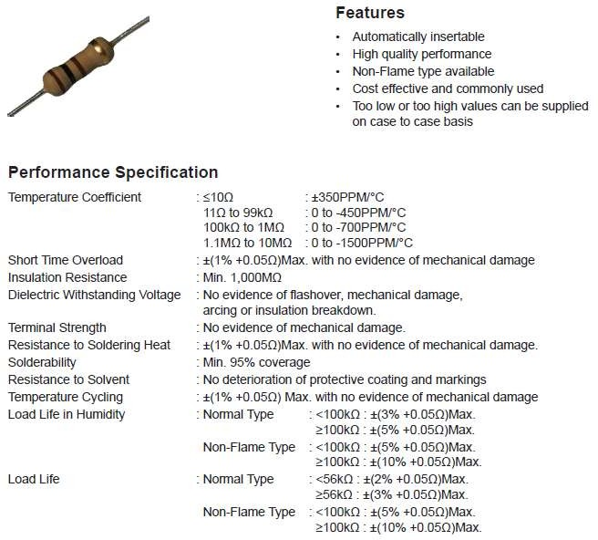

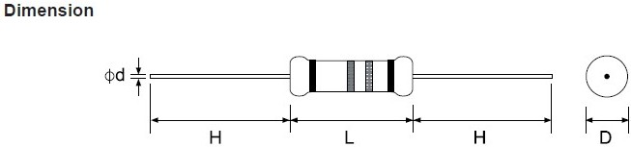

Specification:

* + Step down transformer 230V/12V
  + Operating frequency is 50HZ
  + Voltage is converted from 230 V to 12 V
  + Current rating is 1A.

Low voltage power is described as power supplied from a transformer of 30 volts or less. The transformer actually steps down and converts 230 volt power to 30 volts or less. Transformers are normally mounted on a junction box. Sometimes transformers have more than one voltage connection point, called a multi-tap transformer.

Transformers are constructed of two tightly wound coils encased in a metal cover. Since the two coils are placed closely together in the case, current flows through the primary winding (the 120- volt side) and as it does this, it produces a magnetic flow. This flow produces current in the second coil winding (secondary winding) that produces the low voltage output.

The primary coil has more windings than the secondary coil. Because of the reduced number of windings in the secondary coil, the voltage output is much less. Secondary windings usually produce voltages between 8 and 24 volts. An electronic low voltage transformer also contains an electronic device, called an inverter, which allows the size of the low voltage transformer to be substantially smaller. An inverter and a small transformer make up the main components of what we normally call an electronic low voltage transformer.

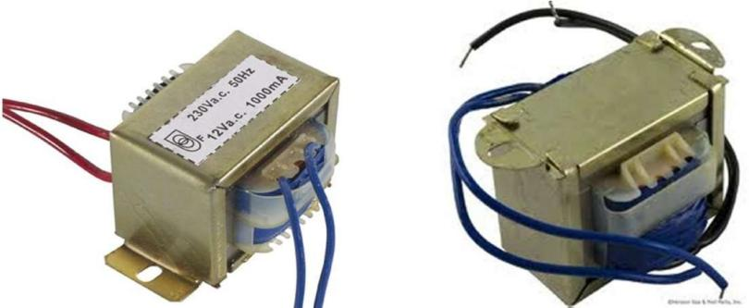

## Step Down Transformer (230v – 12v)

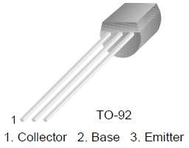

Absolute maximum Rating:

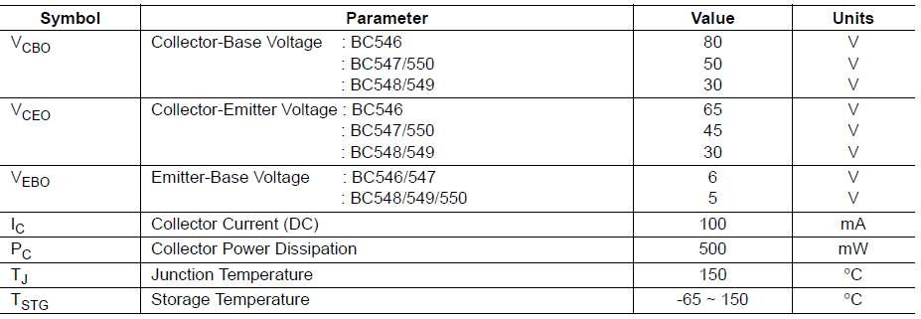

Electrical Characteristics:

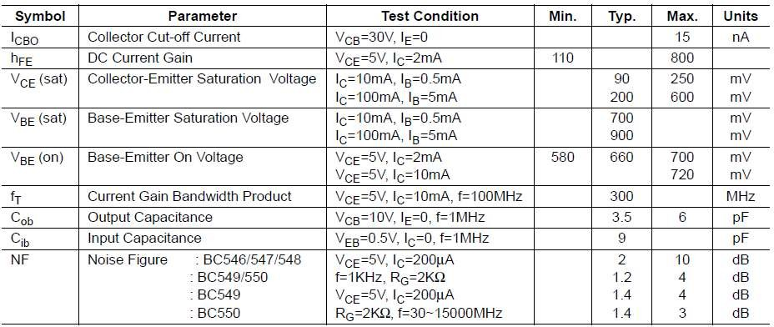

Pin Configuration:

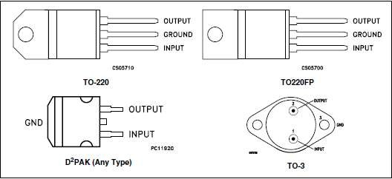

Schematic Diagram:

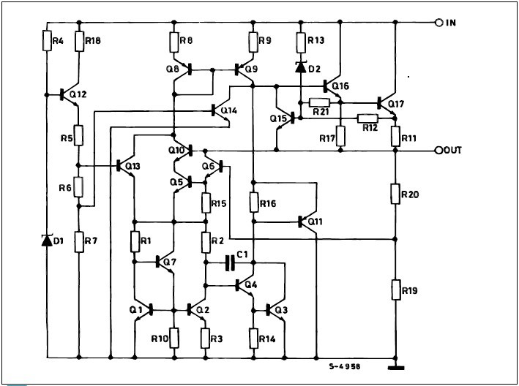

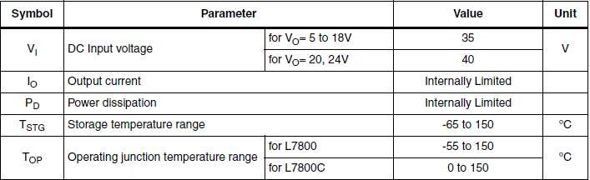

Thermal Data:

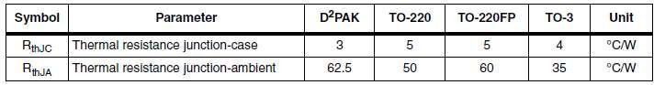

Application Circuit:

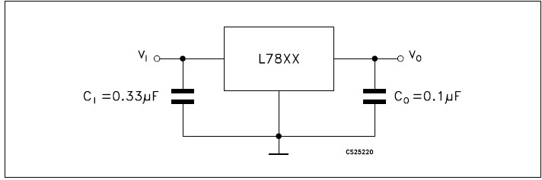

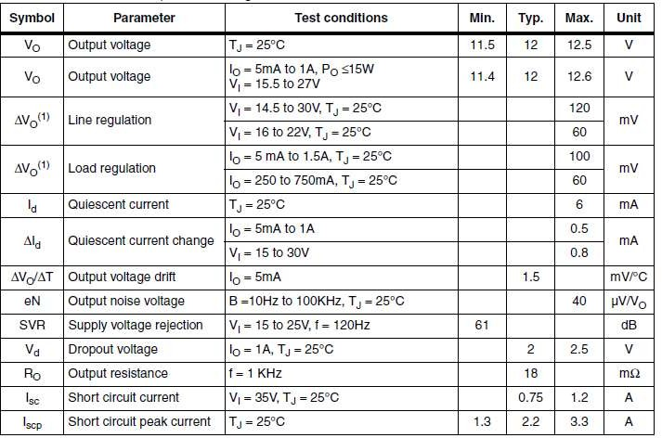

## Zener Diode:

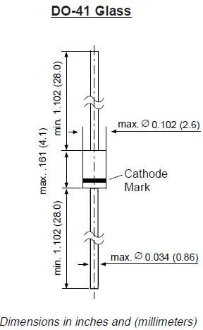Features:

* + Silicon Planar Power Zener Diodes
  + For use in stabilizing and clipping circuits with high power rating.
  + Standard Zener voltage tolerance is ±10%. Add suffix “A” for ±5% tolerance. Other Zener voltages and tolerances are available upon request.
  + These diodes are also available in the MELF case with type designation ZM4728 thru ZM4764

Maximum Rating:

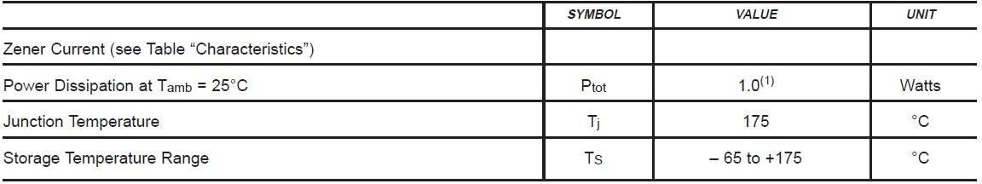

Characteristics at Tamb=25˚C:

